
UNIVERSITY OF ENGINEERING AND TECHNOLOGY PESHAWAR, JALOZAI CAMPUS
Lab 4: Define Your Own Function
Lab Title: Introduction to AI Programming
Note: Using the internet is encouraging for finding relevant code and modifying it for the problem at hand.
Time: 10 min/ Task
Lab Report Tasks:
In circuit design, you often calculate series resistance.
- Write a function series() that takes a list or tuple of resistances.
- Return the total resistance.
- Add docstrings and annotations.
- Print the function’s __annotations__.
Lab work tasks:
- Student Record System:
- You are making a small program for your university to store student details.
- Define a function that takes a student’s name and registration number and prints them.
- Try calling this function using:
  - Positional arguments.
  - Keyword arguments.
  - Default arguments
- Test what happens if you pass fewer arguments than required.
- Check if Python allows a positional argument after a keyword argument.
- Ohm’s Law Calculator:
- In your electrical lab, you need to calculate the voltage across a resistor.
- Define a function that takes current (I) and resistance (R) and returns the voltage (V = I × R).
- Call the function using positional, keyword, and default arguments.
- Try mixing argument styles.
- See what happens if you miss an argument.
- Solar Battery Charging:
A solar inverter monitors the battery’s state of charge (SOC).
- Write a function charge_from_solar(SOC) that:
  - Prints "Charging" if SOC < 20%.
  - Prints "Battery full, no action" if SOC > 90%.
  - Prints "Battery charging, SOC = ---%" otherwise.
- Add docstrings and function annotations.
- Print the function’s docstring to check.
- Resistance, Voltage, and Current Lists:
You are building a program to analyze five resistor values in a circuit.
- Function 1: resistance(): return a list of 5 resistances.
- Function 2: voltage(): return voltages across each resistor.
- Function 3: current(): take both lists (Resistance & Voltage) and calculate currents.
- Display all lists nicely in the main program.
- Try two versions:
  - Return as a tuple.
  - Return as a dictionary with keys like "current_1".
- Series Resistance:
In circuit design, you often calculate series resistance.
- Write a function series() that takes a list or tuple of resistances.
- Return the total resistance.
- Add docstrings and annotations.
- Print the function’s __annotations__.
- Parallel Resistance:
Now, calculate parallel resistance.
- Write a function parallel() that takes a list or tuple of resistances.
- Return the equivalent resistance.
- Add docstrings and annotations.
- Print the function’s __annotations__.
- Series Resistance with *args:
You now want to make the series resistance function more flexible.
- Define series(*args) using tuple packing.
- Pass any number of resistances.
- Return the total resistance.
- Add docstrings and annotations.
- Print __annotations__.

- Parallel Resistance with *args:
Do the same for parallel resistance.
- Define parallel(*args) using tuple packing.
- Pass any number of resistances.
- Return the equivalent resistance.
- Add docstrings and annotations.
- Print __annotations__.
- Solar Inverter Data (Tuple/List):
A solar inverter gives data as [SOC, solar_generation, price]. Example: [60, 2, 60].
- Define a function that takes this list/tuple.
- Print each value in a nice format.
- Use list or tuple unpacking.
- Add docstrings and annotations.
- Print __annotations__.
- Solar Inverter Data (Dictionary):
A better inverter sends data as:
{ "SOC": 60, "solar_generation": 2, "price": 60 }
- Define a function that receives this dictionary.
- Print the values in a clear format.
- Use dictionary unpacking.
- Add docstrings and annotations.
- Print __annotations__.
- Solar Inverter Data (Keyword Arguments):
Sometimes, data is passed as:
solar(SOC=60, solar_generation=2, price=60)
- Write a function that receives these keyword arguments as a dictionary.
- Print the values in a nice format.
- Add docstrings and annotations.
- Print annotations .

- Write a Python function that computes the derivative of a simple quadratic function $y=x^{2}.$
Define a Python function dy_dx(x) that returns the analytical derivative dy/dx=2x
- Chain Rule

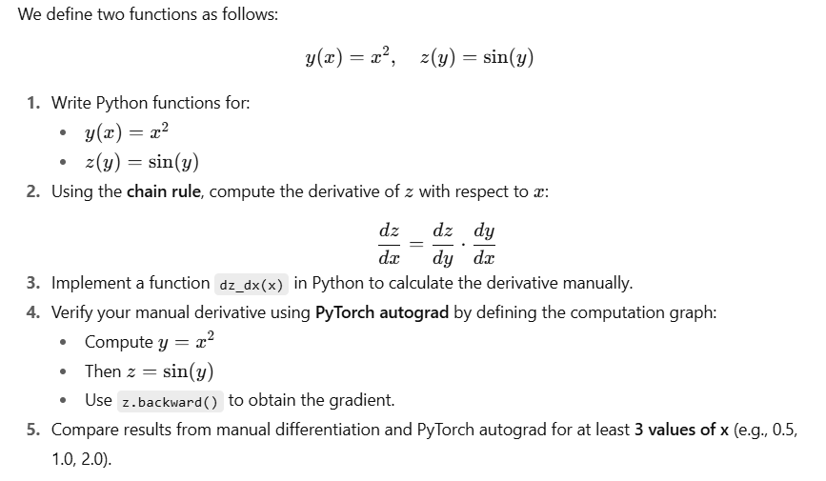

Note:

Annotations:
In Python, annotations are hints that show what type of data a function expects and what it will return. They do not affect how the program runs but make the code easier to understand. (voltage.__annotation__)

*args:
In Python, *args lets a function accept any number of positional arguments.
It collects them into a tuple inside the function.

Docstrings:
A docstring is a special string written inside a function (or class/module) to explain what it does.
It is written inside triple quotes ( """ ... """ )
Function Arguments and Annotations:
You are working as a junior engineer and your team leader asks you to practice advanced function features in Python.
Your task is to run, modify, and design scenarios using functions with *args, **kwargs, and annotations.
Task 1: Function with All Types of Arguments:
def f(a, b, *args, **kwargs):
print(f'a = {a}')
print(f'b = {b}')
print(f'args = {args}')
print(f'kwargs = {kwargs}')
f(1, 2, 'foo', 'bar', 'baz', 'qux', x=100, y=200, z=300)
What to observe:
- a and b are normal positional arguments.
- Extra values are stored in args (tuple).
- Named arguments are stored in kwargs (dictionary).
Task 2: Function with Only *args:
def f(*args):
for i in args:
print(i)
a = [1, 2, 3]
t = (4, 5, 6)
s = {7, 8, 9}
f(*a, *t, *s)
What to observe:
- You can unpack lists, tuples, and sets into a function.
- *args collects them into a single tuple.
Task 3: Function with Only **kwargs:
def f(**kwargs):
for k, v in kwargs.items():
print(k, '->', v)
d1 = {'a': 1, 'b': 2}
d2 = {'x': 3, 'y': 4}
f(**d1, **d2)
What to observe:
- **kwargs collects named arguments into a dictionary.
- Dictionaries can be unpacked directly into a function.
Task 4: Mixing *args in Function Calls:
def f(*args):
for i in args:
print(i)
f(*[1, 2, 3], *[4, 5, 6])
What to observe:
- You can pass multiple unpacked lists into *args.
- All values are combined into a single tuple.
Task 5: Mixing **kwargs in Function Calls:
def f(**kwargs):
for k, v in kwargs.items():
print(k, '->', v)
f(**{'a': 1, 'b': 2}, **{'x': 3, 'y': 4})
What to observe:
- Multiple dictionaries can be unpacked into one **kwargs.
Task 6: Using Annotations:
def f(a: int, b: str) -> float:
print(a, b)
return 3.5
f(1, 'foo')
print(f.__annotations__)
What to observe:
- Annotations are type hints, not restrictions.
- They show expected input/output types.

Task 7: Annotations with Default Values:
def f(a: int = 12, b: str = 'baz') -> float:
print(a, b)
return 3.5
print(f.__annotations__)
f()
What to observe:
- Default values work along with annotations.
- Annotations do not enforce type rules.
Task 8: Annotations Ignored by Python:
def f(a: int, b: str) -> float:
print(a, b)
return 1, 2, 3
f('foo', 2.5)
What to observe:
- Function annotations don’t force types.
- You can break the rules, and Python will not complain.

Best of luck!

